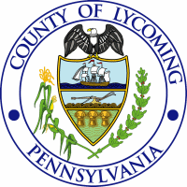
COUNTY OF LYCOMING
PURCHASING DEPARTMENT

Phone: (570) 327-6701

Fax: (570) 320-2111
www.mtoon@lyco.org

VENDOR APPLICATION FORM

COMPANY INFORMATION:

Company Name:

Address:

City: State: Zip:

CONTACT INFORMATION:

Contact Person:

Phone Number: Fax Number:

E-Mail Address:

TYPE OF ORGANIZATION:

Individual Ownership Joint Venture Partnership
Non-Profit Organization Corporation
Other

PRODUCTS / SERVICES OFFERED:

Audio Visual Maintenance Equipment / Supplies
Computer Cabling Office Equipment
Computer Equipment Office Supplies
Food Service Uniforms
Furniture Vehicles
Janitorial Equipment / Supplies Other

NOTE: Vendors desiring to participate in Lycoming County’s open and competitive procurement process should complete and submit a vendor application form. Vendor applications forms may be emailed or faxed to the email address and fax number shown above to the attention of Mya Toon, Chief Procurement Officer.

Placement on the bidders list is a service provided for your convenience. Inclusion is not a binding assurance of future solicitation. Lycoming County is not obligated to directly notify past or present bidders. To ensure bid / proposal participation, check for notices in the Williamsport Sun-Gazette or Lycoming County’s Purchasing Department website at www.lyco.org and click on Top 10 Links, Request for Bids / Proposals.

